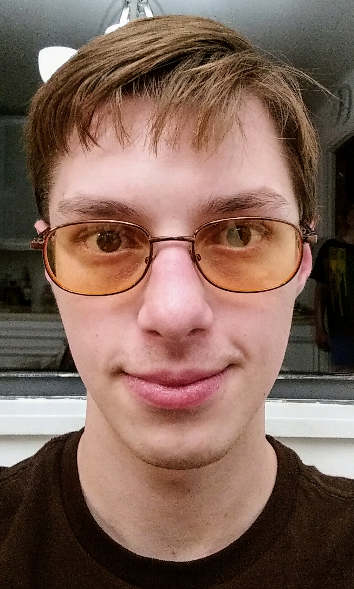
Michael Thomas Lynn
800 S. Timberland Drive Lufkin, Texas, 75901
936-404-3467
MichaelTLynn@protonmail.com
michaellynn.neocities.org

Physicist turned roboticist, I am tremendously driven, I enjoy solving hard problems, and I am absolutely determined to build a future worth living in. My greatest power is to learn and adapt to solve any problem, taking advantage of all available attack surface given some time.

Experience
Chic-Fil-A – (6 months) I served as a cashier, wait staff and janitorial assistant. I served food to customers, counted change, ran a drive through window and generally worked as a member of a well oiled machine serving delicious fast food to over 750 people a day for 2 summers. I learned much about the importance of fast, quality service and what life was like on the other side of the counter.
CRIS Helpdesk – (1 year) I provided technical support to police officers on the use of a new Crash Reporting Information and Statistics platform for the better part of a year. I troubleshooted network errors and responded to quality complaints about the software via a issue tracking system and phone calls.
Young Entrepreneur- (5 years) I set up and administered small business networks, business computing and financial management systems. I provided general IT, security and remote support expertise as a consultant for 5 years. I learned skills in quick-books, Linux, excel, file transfer protocol, web-hosting, advertising, accounting, tax code, customer management, customer relations, phone systems and TCP/IP, scripting in Bash, Python, LISP and much more. Most importantly, I learned a little of how to communicate and think for myself in business, and how to handle myself around older, wiser, and sometimes frustrated clients.
First Mentor/Team Leader- (8 years) I organize, motivate, direct and mentor high school students as they design, construct and test large robots, as a member and mentor of FIRST robotics team 2582. For 8 years I have been instrumental in the mechanical, electrical, and software development and integration for the team, and have learned much in my experimentation as I grew, from member, to team lead, to mentor. I am most proud of teaching the students to build OpenCV computer vision systems and PID control to make their robot really come to life!
Bridgeway Software Engineering Summer Intern- (3 months) I assisted the engineers in debugging, management and optimization of xml datbases and cross application API systems. I developed Python scripts to search, sort, and rapidly edit large volumes of PyLint and Datomic error outputs and client side failure cases. I cut pylint error sorting time by 33% using a Bash script to automate selection of error outputs through regular expressions and some crafty greping!
Engineering Student Organization Treasurer- (6 months) I managed the finances of the organization, providing fund raising and organizational support for activities and projects. I increased organization funding 50% year over year and added 6 additional members in my first semester in the organization!I co-founded programs for constructing 3d-printed drones, a 400 lb Assa Abloy Sound proof door, and in funding a motion controlled tetris machine!
Engineering Student Organization President- (1 year) I organize, mentor and lead an organization of 36 undergraduate students in networking with engineers, businesses, and educators, as well as in extra curricular projects, including the founding of a BEST robotics program for local Nacogdoches high schools, the completion of a FPGA based, gesture controlled tetris machine, development of a USB game controller for parapalegics, and much more. The organization has more than tripled in membership and experienced a 65% growth in revenue and activity attendance under my leadership, I am quite proud of this!
Research Assistant for NSF grant- (2 years)I proposed an idea to my research advisor and mentor, found a set of matching grant programs and subsequently drafted and submitted a successful grant proposal! Our funded research includes the study of an advanced type of actuator made from off the shelf polymer materials, supercoiled into super strong, lightweight, power dense actuators with power to mass ratios exceeding 5 Kw/Kg! These simple devices could revolutionize the actuator industry!

Research Interests and Progress
Connectomics- I explored and extended the functionality of the Open Worm project’s Open connectome engine. I studied the way modified recursion in the abelian matrices of the connectome program effected the worm’s behavior. I discovered that greater recursion led to greater motor activity and promoted greater responsiveness in the program.
Robotics- I study the function and design of Twisted Coiled Polymer Actuators. I am improving their commercial viability by characterizing a multitude of different material and structural variations in an environmental chamber and optimizing for work efficiency and power density. I then collaborate with a chemist to devise polymer combinations that maximize the traits that best improve performance by my characterization results. These exciting devices consist of cheap, widely available polymer materials and have the potential to revolutionize actuation across industry.
Synthetic Biology and OptoGenetics- I study the feasibility and potential socio-economic impacts of near term bio-engineering and scientific developments, especially, reproductive and therapeutic cloning, optogenetic enhancement, engrammatic programming, genetic and epigenetic sequencing, Cryo-biology and accelerating spatiotemporal resolution in medical imaging.
Brain Machine Technologies- I study brain machine interface techniques through EEG and FNIR headsets and clever mathematical applications. Optimizing the use of what data is cheaply and readily available on brain function at the large region scale allows me to build skills and understanding that could be of value when better measurement and recording technologies become more readily available. Work includes, using fourier analysis to filter brain wave signals for control of motors and other basic equipment, and use of unsupervised learning methods to infer and analyze neuronal population and brain region dynamics.
Nanotechnology and Femtotechnology- I study the development and impact of nano scale machinery and model possible future evolution of such technology. One such permutation is femtotechnology, or the manipulation of individual nucleons to form degenerate systems from nuclear molecules. Such systems do not presently exist in the lab, but their mathmatical modeling and the study of the physics that could construct such a system and that would be at work in such objects is great exercise.
Gravitational Black Bodies and QFT- I am re-deriving a description of relativistic gravity, based on black body radiation analogues of space time curvature and mass energy equivalence. I wish to describe all space time curvature in terms of concentrated mass energy and re-emitted matter waves.
In short, I may be developing a contender for a description of quantum gravity and the missing dark matter/energy problems simultaneously; But this remains to be seen.
Immortality- I seek Immortality and stay abreast of current developments in anti-aging, geriatric therapeutics, regenerative medicine, cybernetics, cryonics, genetic engineering and much more. This leads me to studying the philosophy of long time scales, economic dynamics and modeling as well as to developing an interest in nation building and sustainable politics/societal construction. I seek sustainability and quality in everything I do, because I plan to be around to see the consequences of my actions and those of others. Additionally, I study and attempt to model the impacts of post-human development and the evolution of the human species into non-human species over the short, medium and long terms, in response to technological, and evolutionary drivers.

Skills
Mechatronics, Physics, High Level Mathematics, Critical Thinking, Software Development, Engineering design, FPGA programming, Microcontroller programming, rapid prototyping, teamwork, C++, C#, Perl, Python, LISP, Java, Ruby, HTML, PHP, TCP/IP, Communication, leadership, mentoring, Speech writing, Technical Writing, Creative Writing, Biological knowledge, Neuroscience Knowledge, Determination, Accounting, Tax code, business, information security, cyber security, interpersonal communication, Microscope use, STM and TEM usage and maintenance, adaptation, learning, web search, deep web search, SEO, Marketing, advertising, networking, agile development, cooking, PCR operation, genetic sequencing, bioinformatics, PAC-MOL simulation, LAMMPS, Connectomics knowledge, computational methods, Numerical Methods, Differential Equations, Fourier Analysis, Complex Numerical Analysis, Chemistry, and much more!

Education
BS, Physics, Stephen F. Austin State University, Nacogdoches Texas, Spring 2018
Minor in math and some computer science coursework
Courses focused heavily on critical thinking and analytic skills, substantial calculus 3, differential equations and mathematical applications to physical problems. Determination is a must!
Engineering Student Organization
Society of Physics Students
IEEE chapter founding member
ASME chapter founding member
High School Diploma, Lufkin High School, Lufkin Texas, Spring 2014
STEM focus
Robotics team member and leader, eventually a mentor
Debate Team, State competitor
Computer Science UIL founding member
A-B student
Test Scores
SAT – 1858
ACT – 29

Talks and Publications
APS talk over Twisted Coiled Polymer Actuators
https://www.youtube.com/watch?v=YJzdtgj7G38

